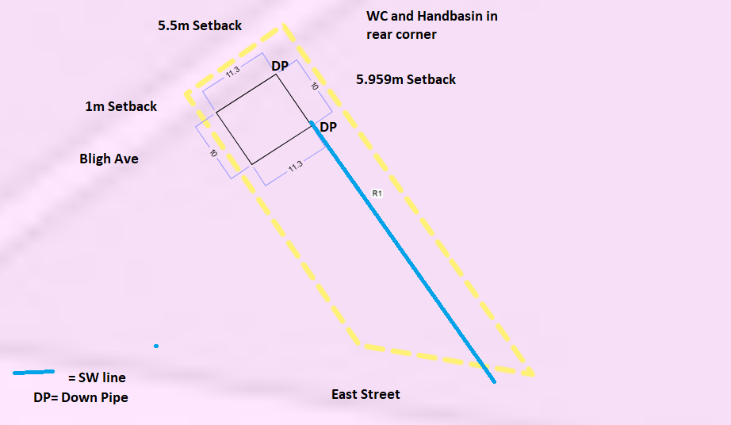
Site Plan – 23 East Street Uralla NSW 2358.
Proposed Shed with WC and Handbasin

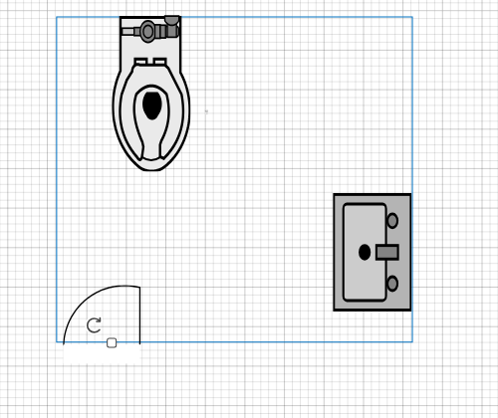
Proposed 2m x2m WC and Handbasin room in rear corner of shed as per above site plan.

